TATA MEMORIAL HOSPITAL
TATA MEMORIAL CENTRE
DR. ERNEST BORGES MARG
PAREL, MUMBAI 400 012
Tel: 022-24177000 Extn. 4642
Fax: 022-24136777
Email: capitalequip@tmc.gov.in

Tender Documents

- Notice for invitation of Tender
- Instructions to the Supplier.
- Tender Form – Application.
- Schedule of Specification of the item tendered and Compliance report on the prescribed form (excel) and on CD.

- Conditions of the tender (General as well as special).

- Valid Letter of authority from the Principal to the Indian agent duly signed, executed and stamped.

- Undertaking for installation, commissioning and providing training to the nominated staff and replacement of spare parts / consumables and supply thereof during the warranty as well as maintenance contract period.

- Disclosure of existing customers to whom supply of equipment / service made available in India.

- Commercial Offer form – Price Bid form.

For TATA MEMORIAL HOSPITAL

Serial # 2

Instructions to Suppliers
Suppliers are requested to take note of the following instructions while filling the Tender form for submission of Technical and Commercial offer:

- The tenderer should furnish the full contact details such as recent phone nos., mobile nos., email id, mailing address, office address which will be in operation for a period of two years. TMC will send all communication preferably by e-mail. Non receipt of communication will not be our responsibility. So tenderer must ensure correct and operational email ID and fax Nos. If any changes in contact details then ensure to submit to TMC.

- The bidder should be having a legal entity either of individual/partners or a body corporate which may sue or may be sued.

- The bidder should be competent enough to deal with the business of the tendered item technically and financially and should have adequate man-power having prescribed qualification (Skilled & Technical) required for managing the business.

- The bidder should have necessary license under the prevailing laws of the land and competent to undertake import and export process of goods and services.

- The bidder should have tax payment capability by producing 3 years Assessment Clearance Certificate as and when asked for in addition to PAN and GST No.

- The bidder should provide Service tax No. and License No. as may be required for manufacturing of item and/or import from foreign origin.

- Experienced bidder should attach certificate of their past experience in support of their capability in the field of dealing with the item tendered.

- The successor / heirs in office will be responsible for the liabilities created by the bidder in respect to the item / services offered by bidder.

- The risk of loss in transit of the goods / services shall be the responsibility of the bidder.

- The bidder will be solely responsible for the activities if found fraudulent on the part of principal to cheat or swindling the Indian public by way of advance payment or breach of terms and condition of L/C established for import of tendered item.

- The bidder will be responsible for abiding the international laws including rules relating to package etc. applicable to the item / services offered by the bidder.

- The bidder will be responsible for ensuring that the international standards before the consignment of the item is dispatched from the godown of manufacturer of foreign origin to deliver into India at the place of the user.

- The bidder will be responsible for safe transit of the goods under proper goods insurance coverage and under standard conditions.

- The supplier should have a team comprising of experts of the line for erection, installation, commissioning and maintenance of the equipment/article tendered for use in the public interest.

- The bidder should inform in advance to the Institute about the requirement for the erection, installation and commissioning indicating the additional amount of charges/expenditure by the bidder. A separate turnkey proposal shall be submitted if the supplier undertakes to modify the existing infrastructure to suit the installation of the proposed equipment. In normal course the letter of intent will include the costs of the equipment and its installation.

16. Eligibility criteria as per OM Dated 23.07.2020 (Copy uploaded separately) issued by MoF w.r.t amendment of GFR
- Any bidder from a country which shares a land border with India will be eligible to bid in this tender only if the bidder is registered with the Competent Authority.
- "Bidder" (including the term 'tenderer', 'consultant' or 'service provider' in certain contexts) means any person or firm or company, including any member of a consortium or joint venture (that is an association of several persons, or firms or companies), every artificial juridical person not falling in any of the descriptions of bidders stated hereinbefore, including any agency branch or office controlled by such person, participating in a procurement process.
- "Bidder from a country which shares a land border with India" for the purpose of this Order means: -
- An entity incorporated , established or registered in such a country; or
- A subsidiary of an entity incorporated , established or registered in such a country; or
- An entity substantially controlled through entities incorporated , established or registered in such a country; or
d. An entity whose beneficial owner is situated in such a country; or
e. An Indian (or other) agent of such an entity; or
f. A natural person who is a citizen of such a country; or
g. A consortium or joint venture where any member of the consortium or joint venture falls
under any of the above

- The beneficial owner for the purpose of (iii) above will be as under:

In case of a company or Limited Liability Partnership, the beneficial owner is the natural person(s), who, whether acting alone or together, or through one or more juridical person, has a controlling ownership interest or who exercises control through other means.
Explanation-

- "Controlling ownership interest" means ownership of or entitlement to more than twenty-five per cent. of shares or capital or profits of the company ;

- "Control" shall include the right to appoint majority of the directors or to control the management or policy decisions including by virtue of their shareholding or management rights or shareholders agreements or voting agreements ;

- In case of a partnership firm, the beneficial owner is the natural person(s) who, whether acting alone or together, or through one or more juridical person, has ownership of entitlement to more than fifteen percent of capital or profits of the partnership;

3. In case of an unincorporated association or body of individuals, the beneficial owner is the natural person(s), who, whether acting alone or together , or through one or more juridical person, has ownership of or entitlement to more than fifteen percent of the property or capital or profits of such association or body of individuals ;
4. Where no natural person is identified under (1) or (2) or (3) above, the beneficial owner is the relevant natural person who holds the position of senior managing official;

5.. In case of a trust, the identification of beneficial owner(s) shall include identification of the author of the trust, the trustee, the beneficiaries with fifteen percent or more interest in the trust and any other natural person exercising ultimate effective control over the trust through a chain of control or ownership.

- An Agent is a person employed to do any act for another, or to represent another in
dealings with third person.

VI Applicable, if scope of requirement includes Turnkey: The successful bidder shall
not be allowed to sub-contract works to any contractor from a country which shares
a land border with India unless such contractor is registered with the Competent
Authority.

Certificate for Tenders (for transitional cases as stated in para III above)
“ I have read the clause regarding restrictions on procurement from a bidder of a country which shares a land border with India : I hereby certify that this bidder is not from such a country and is eligible to be considered.”

Certificate for Traders:
“ I have read the clause regarding restrictions on procurement from a bidder of a country which shares a land border with India : I certify that this bidder is not from such a country or, if from such a country, has been registered with the Competent Authority. I hereby certify that this bidder fulfills all requirements in this regard and is eligible to be considered. (Where applicable, evidence of valid registration by the Competent Authority shall be attached)”.

Certificate for Tenders for Works involving possibility of sub-contracting.:
“ I have read the clause regarding restrictions on procurement from a bidder of a country which shares a land border with India and on sub-contracting to contractors from such countries; I certify that this bidder is not from such acountry or, if from such a country, has been registered with the Competent Authority and will not sub-contract any work to a contractor from such countries unless such contractor is registered with the Competent Authority. I hereby certify that this bidder fulfills all requirements in this regard and is eligible to be considered. (Where applicable, evidence of valid registration by the Competent Authority shall be attached.)”

Certificate for GeM:
“ I have read the clause regarding restrictions on procurement from a bidder of a country which shares a land border with India: I certify that this vendor/bidder is not from such a country or, if from such a country, has been registered with the Competent Authority. I hereby certify that this vendor/bidder fulfills all requirements in this regard and is eligible to be considered for procurement on GeM. ( Where applicable, evidence of valid registration by Competent Authority shall be attached.)

- Preference to Make in India products (For bids < 200 Crore): Preference shall be given to Class 1 local supplier as defined in public procurement (Preference to Make in India), Order 2017 as amended from time to time and its subsequent Orders/Notifications issued by concerned Nodal Ministry for specific Goods/Products. The minimum local content to qualify as a Class 1 local supplier is denoted in the bid document. If the bidder wants to avail the Purchase preference, the bidder must upload a certificate from the OEM regarding the percentage of the local content and the details of locations at which the local value addition is made along with their bid, failing which no purchase preference shall be granted. In case the bid value is more than Rs 10 Crore, the declaration relating to percentage of local content shall be certified by the statutory auditor or cost auditor, if the OEM is a company and by a practicing cost accountant or a chartered accountant for OEMs other than companies as per the Public Procurement (preference to Make-in -India) order 2017 dated 04.06.2020. Only Class-I and Class-II Local suppliers as per MII order dated 4.6.2020 will be eligible to bid. Non - Local suppliers as per MII order dated 04.06.2020 are not eligible to participate. However, eligible micro and small enterprises will be allowed to participate. In case Buyer has selected Purchase preference to Micro and Small Enterprises clause in the bid, the same will get precedence over this clause.

- Purchase preference to Micro and Small Enterprises (MSEs): Purchase preference will be given to MSEs as defined in Public Procurement Policy for Micro and Small Enterprises (MSEs) Order, 2012 dated 23.03.2012 issued by Ministry of Micro, Small and Medium Enterprises and its subsequent Orders/Notifications issued by concerned Ministry. If the bidder wants to avail the Purchase preference, the bidder must be the manufacturer of the offered product in case of bid for supply of goods. Traders are excluded from the purview of Public Procurement Policy for Micro and Small Enterprises. In respect of bid for Services, the bidder must be the Service provider of the offered Service. Relevant documentary evidence in this regard shall be uploaded along with the bid in respect of the offered product or service. If L-1 is not an MSE and MSE Seller (s) has/have quoted price within L-1+ 15% (Selected by Buyer) of margin of purchase preference /price band defined in relevant policy, such Seller shall be given opportunity to match L-1 price and contract will be awarded for 25%(selected by Buyer) percentage of total QUANTITY.

- The bidder will be responsible for all the consequences legal or administrative with regard to the persons involved in erection, installation, commissioning & maintenance for compensation in case of any damage occurred to them while execution of the work.

20. The bidder will be under obligation to intimate to institute in advance about the assistance to be extended by the institute without involvement of expenditure or at the cost of the bidder in connection with the process of erection installation and commissioning.

21. The bidder is responsible for installation and commissioning of the equipment without damaging infrastructural image/face of our building/installation site. Temporary destruction and re-construction of existing structure in connection with the site preparation and installation of the equipment will be the vendor’s responsibility. Charges/expenses involved for the same shall be borne by the supplier. If any damage takes place while the work is in progress, from any cause whatever or if any defect, shrinkage or other faults appear in the work, the bidder shall make good the same at his own cost.

22. The bidder should obtain clearance from structural consultant before starting the work (wherever applicable).

23. The installation certificate will have to be issued by the team of the experts and it should be countersigned by the user or Authorized person and the date on which such certificate is counter signed by will be the date from which period of warranty commence.

24. The bidder should ensure that the technical bid complete in all respect should be sealed in a separate cover and commercial/price Bid should be sealed in separate cover and both the envelopes should be kept and sealed in a suitable size cover which should be super scribed with name of the equipment, tender No. & the EMD receipt number and date.

The vendor who is registered with MSME/NSIC should enclose a photo copy of MSME/NSIC certificate. (MSME/NSIC vendors are exempted from tender document charges of Rs. 500/- and EMD)

MSME/NSIC certificate or Receipt of tender document charges of Rs.500/-is to be enclosed in the technical bid and a copy of the same must be shown on or before submission of the tender. Tender document charges for the tender forms downloaded from our website must be paid at the cash counter, 1st floor Homi Bhabha Builiding.

25. The bidder are also advised to ensure that the Commercial offer and the Technical offer papers are signed by the authorized persons and rubber stamp should be put wherever asked for.

26. The offers should be submitted within the scheduled time limits and delay if any occurred in
submission on account of any reason whatsoever shall not be condoned and such delayed offers received late shall be liable for rejection.

27. The bidder or his authorized representative will be entitled to participate in the tender opening
process to take note of the proceedings of disclosure.

28. The bidder may contact the following relating to any of the item published in Tender Notice;

- Head, Cafeteria Dept. Tel No. : 022 24177000 Extn 4610 for technical clarification of equipment.
- Bio-Medical Engineer at Tel No: 022 24177000 Ext 7237 for technical clarification.
- Purchase Dept. at Tel No. : 022 24177000 Ext 7063, 4642 for any other clarification.

29. Any change in policy decision made by the TMC management before awarding the

contract will be binding on the vendor.

30. Conditional & incomplete offers will not be accepted.

31. The Director, TMH / TMC reserves the right of cancellation, adding, reducing or deferring the purchase without assigning any reason thereof at any stage in the processing of tenders received and no claim in this behalf from any tender in any way shall be entertained/tenable/entitled for compensation in one way or the other. In such case of cancellation the bidder will be refunded with the earnest money deposit without any payment of interest on production of original EMD receipt. The Director, TMC on enquiry will disclose the reasons for rejecting a tender or non-issuing a tender document.

Certified that I have read the above instructions carefully and taken note of them.

Signature

Date: Name of authorized person for bidder with seal

Serial # 3

TATA MEMORIAL HOSPITAL

TATA MEMORIAL CENTRE
PAREL, MUMBAI 400 012

TENDER FORM
Application
Ref: Tender No: Date:
  - Name of the Item / Work
2. Due Date of the submission of the
tender / Bid
3. EMD Receipt No., Date & Amount
4. Name / Title of the Bidder
5. Full Address (Recent)

- Tel. No & Mobile No. (Recent)
- Fax (Recent)
- E-Mail (Recent)
6. Name of the person authorized to deal / undertake business for and on behalf of the bidder

- Tel. No & Mobile No. (Recent)
- Fax (Recent)
- E-Mail (Recent)
7. Legal entity of the bidder whether Firm / Society / Company / Other entity
- Registration No. | - Authority with whom registered
- License No. granted by
8. Main business of the bidder whether Manufacturer, Business Distributor, Wholesale Dealer, Retail trader or Service Agent
9. Authorized Area of operation in India
10. Name of the Principal Organization / Company for and on behalf working in India
11. Origin of the Principal Organization / Company
12. Address of the Principal Organization / Company

- Contact Person Name:
- Designation:
- Tel. No. & Mobile No.:

- Fax:

- E-Mail:

13. Bank Details (Attached Cancelled Cheque):

- Bank Name, Branch & Address
- Bank Account No.
- IFSC Code
- MICR Code of the Bank
- Account Type
14. Authority / Delegation / License No. & Date granted by the principal to the representative bidder
15. PAN No.
16. Registration No. granted by Central Excise Commissioner for Service tax
17. GST No.
18. HSN & SAC code of the product:
19. Import / Export Code No.
License No. for import
20. No. of manpower employed by the bidder | a. Scientific b. Technical
 | c. Administrative d. Finance
21. Support facility equipment No.
22. Experience of the bidder in dealing with the tendered item. Tenderer must have similar job done in the line of business / experience with 3 to 8 years will be considered
23. Whether supply of any item / service to TMC in past; if yes indicate the Purchase Order No. & Date
24. Any other relevant information for submission

I, certify that the above information is correct & true to the best of my knowledge and belief. Nothing has been concealed and fabricated and in case any information is found incorrect then I, the under signatory will be personally responsible.

Signature

Date: Name of authorized person for bidder with seal

Serial # 5

TATA MEMORIAL HOSPITAL
TATA MEMORIAL CENTRE
DR ERNEST BORGES MARG
PAREL, MUMBAI 400 012

GENERAL & SPECIAL CONDITIONS OF THE TENDER
- The Director, Tata Memorial Centre, Dr. Ernest Borges Marg, Parel, Mumbai- 400012 invites sealed tender from Original Equipment Manufacturers (OEM) or Authorized Vendors for “Supply, Installation, Commissioning & Maintenance of Medical equipment as per Technical Specifications enclosed for HBCHRC Vizag.

- Tender will be submitted or dropped in the dropped box available in the purchase department in Two Bids in sealed cover super scribed with Tender No. “TMH/VIZ/2022-23/CAP/PT/0055‘’for “Commercial Electrical and Gas Kitchen Equipment”, Qty: Refer BOQ. The tender should contain the technical bid and the commercial bid which would be received on or before 01/11/2022 in the Purchase Department, TMH, at Parel, Mumbai – 400012 up to 4.00 pm. Technical Bids will be opened on 02/11/2022 at 4.30 p.m onwards in the presence of the attending bidders. Time and date of opening of the Price Bid will be intimated only to the bidders who are technically qualified after evaluation of the Technical Bid.

- An Earnest Money Deposit of 1,56,600/- is to be paid (UNDER THE A/C NO. 3568) at Cash counter by DD in favor of “Tata Memorial Hospital” payable at
Parel, Mumbai - 12 and original EMD receipt should be enclosed in Technical Bid of the tender documents. The photocopy of the original EMD receipt must be kept with the vendor and to be shown at the time of tender submission. The Bids received without paying the tender documents charges and EMD charges shall not be considered. In case of e-Tender prescribed processing fees to be paid as per tender notice.

4. The technically suitable offers shall be shortlisted and the commercial bid will be opened of such technically successful bidders only.

5. The concept of lowest commercial offer will be accepted subject to techno suitability.

- The successful bidder will have to enter into an Agreement for the contract of supply, installation, commissioning and maintenance of the equipment including the supply and availability of the spare parts.

7. Successful bidder will be issued with a Letter of Intent if required which will be followed by a Purchase Order.

8. The bidder will also be under obligation to submit the technical specifications & Compliance of the specified item not only in the form of hard copy but also on CD detailing on the left side components and their technical specifications in the prescribed format.

- A complete product catalogue, literature/publication/user information paper should be submitted in the Technical Bid along with the design, drawing etc. including the weight, volume and size of the equipment.

- The bidder may separately quote and submit for other variants including those which are working in progress and likely to be marketed in the next couple of years, if they satisfy the requirement for the specified item / equipment.

- The bidder will also have to certify that the equipment proposed to be supplied is not obsolete and that no new variants are likely to be marketed in the next 2 years. Vendor is responsible to maintain the equipment till the end of its life.

12. The bidder will have to submit the certificate of Disclosure stating that the Model has been supplied to the users with their details i.e. Name, Address and Tel. No. & E-Mail.
13. The bidder will be under obligation to provide training free of charge to the person/s deputed by the hospital for learning of operations and techniques and maintenance thereof in India or abroad as the case may be. The drawing schedule has to be specified in the technical bid.

14 Compliance of National standards of the country of origin of the manufacturer should be certified by the bidder.

15. Literature/Certificate containing the information of the life of the equipment should also be submitted. This criteria is very important and to be noted as a special condition for the tender acceptance.

16 The replacement of defective parts during the warranty period shall be sole responsibility of the supplier and the Indian agent will be solely responsible for replacement at their cost including the down time liquidation damage, customs duty, if applicable etc. be noted as a special condition of the tender.

17 Replacement of 10% of spare parts in a period of first year will amount to the supply of defective equipment and the Principal Company / Indian agent shall be under obligation to replace the entire equipment at their cost.

18 The Indian agent / supplier shall be under obligation to ensure that the delivery of the item / equipment shall be treated as completed only on installation of the equipment on site/place decided by the hospital and commissioning is done at the entire satisfaction of the authorized officer / user scientist. In case the equipment or the item is to be shifted from the place on which it was off-loaded to the site of installation & commissioning, it shall be the responsibility of the agency and no cost in this regard shall be payable by the hospital.

19 The principal supplier or their Indian agent shall be responsible for making the consumable / spares available throughout the life of the equipment at the prescribed discounted rate as may be mutually agreed by the user and denial or non-supply of required consumable / spares shall render the Indian agent liable for liquidated damages under the contract.

20. Technical strength of the bidder for providing supply, installation and commissioning and maintenance thereafter will be the one of the most important criteria for technical suitability.

21 The bidder has been authorized to inspect the site for installation of the equipment without payment of visiting fees to the Institute before submitting its tender, if found necessary, with prior permission. Bidder must be willing to demonstrate equipment functioning to the users at the bidders cost.

22 The compliance report shall be properly filled up and duly signed. In the absence of compliance
report tender will be disqualified and is liable to be reject.

23. Each and every page of the technical offer as well as the commercial offer to be submitted
separately should be signed and sealed. No overwriting is permissible and such document
having correction is liable to be rejected. However, cutting will be permissible on attestation by
the authorized person.

24. If any dispute arises out of the transaction in any manner that shall be resolved by the sole arbitration which shall be appointed by the Director, TMH and in case such person is not acceptable to the supplier, Director-TMC shall be the final and sole arbitrator who shall undertake the exercise of arbitration to resolve the dispute and such award as may be given by Director-TMC shall be final and binding on both the parties. In case of disputes/differences referred as per law to courts, the Honorable Courts in Mumbai will have exclusive Jurisdiction.
Governing Law: The Law in force in India, from time to time shall only have application, and the courts in Mumbai shall have exclusive Jurisdiction to adjudicate the disputes/differences arising out of this contract.

- The Indian supplier on behalf of its Principal supplier / manufacturer of foreign origin shall be under obligation to inform the user from time to time about the innovations / changes made by the manufacturing company in the technique or the program of software to be used in the equipment by way of advancement and will be free to suggest for adoption of the changes at the lowest expenditure as may be acceptable to the users.

- The damages if occurred to the item / equipment during transit up to its installation and commissioning shall be taken care by the supplier / Indian agent either himself or through second party obligation by way of goods insurance to be arranged with a reputed goods insurance company preferably Indian company. In case an insurance policy taken from insurance company of foreign origin that shall be the responsibility of the supplier / agent and no obligation will be there on the part of the purchaser and every step whatever is required to be taken shall be initiated and taken by the agent. The vendor has to arrange Insurance till installation and commissioning of the equipment.

27. Forfeiture of the EMD: If for any reason whatsoever any bidder withdraws his bid at any time prior to expiry of the validity period or after issue of the Letter of intent /work Order, Purchase order, refuses to execute the work order/ Purchase order or furnish the Security deposit and Performance Guarantee for faithful Performance of the contract within the stipulated time, the amount of EMD is liable to be forfeited by TMH.

28. Those vendor who have paid Security deposit / Performance bank guarantee must be taken back by the vendor within 3 months of expiry period. If not collected within 3 months the expired Bank Guarantee shall be destroyed.

Refund of E.M.D.:
a) EMD of the successful tenderer shall be refunded after the security deposit as called for the contract is furnished.
b) EMD furnished by all unsuccessful tenderers will be returned as early as possible after the expiry date of validity of their offer but not later than 30 days of award of the contract.

The vendor who is registered with MSME/NSIC is exempted from payment of EMD and tender document fees of Rs.500/-. The vendor should enclose the photo copy of MSME/NSIC certificate.

29. If the tenderer is not capable of quoting particular item Tenderer should clearly mention in the Technical bid in the compliance report. For the cases where the compliance report the tenderer not mentioned anything then management is free to presume that it is inclusive of the cost quoted by the tenderer.

PART II COMMERCIAL BID
30. In the price bid tenderers should ensure to quote the prices in the prescribed form. If a firm quotes “Nil” charges / consideration, the bid shall be treated as unresponsive and will not be considered. (As per Rule 160 (xiv) of General Financial Rules 2005 vide DAE letter No. 1/5(3)/2012-Budget/ 2483 dated February 20, 2014).

- The detailed price of the equipment should be quoted in Part II of the tender in separate envelope indicating :
- Ex-works cost of the entire equipment with 1 year of warranty and essential accessories and optional accessories separately.
- F.O.B. cost (including handling, inland freight & documentation charges) of the entire equipment and essential accessories and optional accessories separately.
- The freight & insurance charges (up to installation, commissioning and testing).
- Total amount of the equipment on CIF HBCHRC Vizag (exclusive of customs duty), TMC
- The delivery period of the equipment and the time required for installation / commissioning of the equipment must be mentioned.
- The tender of the offer would be CIF HBCHRC Vizag (exclusive of customs duty), TMC as per the International Commercial Terms, applicable at present. All essential spares, consumables, labour and any other incidental costs required for delivering the equipment up to the site of installation and for the startup of the equipment must be included in the commercial bid.
- It shall be the responsibility of the tenderer to arrange for customs clearance and delivery of the equipment at his own cost, risk and consequences. However, the customs duty, as applicable and paid will be reimbursed, at actual, on production of all relevant documents.
- Turnkey price quote (wherever applicable) must be submitted along with part II (Price bid) in the original tender.
Tender without the turnkey price quote (site preparation) shall be summarily rejected.

32. Validity: The tendered offer must remain valid at least for a period of 24 months (2 years) from the date of the opening of the tender.
33. Mode of Payment:
a) Terms of payment for offer in INR: In respect of plant, machinery and equipment 80% payment against delivery at purchase’s site and preliminary inspection and balance 20% after erection, commissioning and final acceptance and submission of 3% Performance Bank guarantee for a warranty period plus three months from date of installation.

b) Terms of payment for offer in foreign currency: Unconfirmed irrevocable letter of credit for 100% payment. All bank charges within India to buyer’s account and Outside India it will be on the sellers account. 90% payment will be released through Letter of Credit on receipt of all required original documents. Balance 10% payment will be released on i) successful installation and commissioning ii) acceptance and certification by the user dept. and iii) submission of 3% performance bank guarantee in INR for warranty period plus three months from date of installation.

34. Warranty: 1 year Warranty

- Warranty period and terms of warranty including accessories, details of preventive / periodic maintenance, frequency and task description must be specified. Vendors are required to provide 1 year warranty. Tenders not confirming to this clause are liable to be rejected.

b) Penalty Clause:

The supplier and/or its Indian agent will be required to give the guarantee towards the performance of the equipment during the warranty period and in case of Annual maintenance contract period for maintaining the equipment in good working condition for a period of at least 300 days out of a period of 365 days a year (i.e. 95% uptime) 24X7. The ten hours non-functioning of the equipment or any part thereof will be considered as one day down time. Total 3000 hours in a year will be considered as Uptime guarantee. Working time is 8.00 a.m. to 6.00 p.m. on week days and 8.00 a.m. to 4.00 p.m. for Saturdays. The equipment shall be fully functional as part of the uptime and if it is partly functional it shall be considered as downtime and deduction shall be made on Pro-rata basis i.e. if the equipment is 70% functional 30% downtime shall be applicable. The decision of the TMC management or its representative in determining the % of the downtime shall be final and binding. Essential period to shut down the installation entirely or partially shall also be included in the down time while calculating the 95% guaranteed uptime i.e. all features as per specifications in purchase order should be functional for uptime. The supplier / agent shall be required to pay a penalty for every day 0.1% of the total cost of equipment per day per machine excluding 150 hours permissible downtime. This rate shall increase commensurate with the rate increase of CMC. If the number of days downtime in each period of 365 days is more than the downtime permissible (which is to be calculated as defined above), the delay for not bringing the equipment in functioning order in any way, directly or even partially will be attributable to the firm. The bidder should provide the details of preventive maintenance to be undertaken through the year. Preventive maintenance is to be done on holidays only. Preventive maintenance and breakdown will not be clubbed. The quarterly CMC bills should be raised at the end and to be supported by preventive maintenance report / breakdown reports, downtime if any and duly signed by Head, user department and will be paid at the end of every quarter only.

Response Time: Should not be more than 06 Hrs. from lodging a breakdown complaint on toll free or by email.

35. Spares parts:
The supplier / Indian agent will be under obligation to provide the price list of all the spare parts required to be replaced after warranty period and should certify that the rates indicated in the price list shall be applicable for the period of 8years after the warranty period.

36. Buyback offer: (IF ANY)

37. Consumables:
- Consumables as may be required for installation, commissioning, start up and trial runs shall be supplied by the supplier with the equipment without any extra charges.
- The price list of such consumables which shall be required for running of the equipment thereafter shall be submitted with validity for the period of 2 years warranty and 8 years thereafter.
- Consumables not covered under CMC shall be listed separately and prices either in INR or foreign currency shall be indicated during the period of CMC.

38. Liquidated damages: In event of failure to supply within the stipulated delivery period, the
purchaser reserves the right to levy liquidated damages @ 2% per month or part thereof for the delayed supplies.

39. Extension: Tender may be extended for a period of maximum 8 years depending upon performance of the tenderers and mutually agreed terms and conditions

40. The amount / % rate of taxes as may be levied should be indicated separately in the commercial offer.

41. The term “without charges or free of cost” will imply as providing goods or services to the
purchaser at no extra charges/cost including tax liability thereon and that the Octroi
exemption will not be provided.

42. The bidders having their warehouses/service center and facilitation center nearby will be
desirable and advantageous for attending the calls to reduce the down-time.

43. The bid should also include the following:
- PAN No., Income Tax details GST No.,
- Profit & Loss a/c & Balance Sheet of the company for 03 years
- Income Tax Return of the firm for 3 years
- Factory License / Shops & Establishment License. Complete Literature of the Product offered.
- Latest Letter of Authority from the manufacturer if the supplier is dealer or agent of the firm.
- Vendor Capability Proforma duly filled in.
- Declaration from foreign agency whether they have a Permanent Establishment or dependent agent in India or not.
- TRC (Tax Residential Certificate) of foreign party (Principals)
- PAN No. of the foreign agency
- Certificate of country of origin of the goods and services offered, to be confirmed by a certificate of origin at the time of shipment.

Special General Terms and Conditions:

Please refer page serial # 9 regarding conditions to identify the lowest tenderer.

- Network (if any) – The requirement of network facility is different for every equipment. Please attach the separate annexure as per the requirement of installation site and vendors to visit the site before submission of tender documents. We need open network facility that has free talk with all available machines.

- Please quote all the models including state of the art. Bidder not quoting their high end model shall be rejected.

- Bidders are advised to submit price bid in the enclosed prescribed format.
- Pre Bid meeting: NA

  - Queries from vendors should reach Biomedical Engineering and Purchase Dept. before 2 working days from the date of pre-bid meeting. Please send your queries tothe following email addresses.
- cafeteria@tmc.gov.in– Cafeteria Mr. Vinit Indulkar
- capitalequip@tmc.gov.in – Purchase Dept.

- Turnkey – Turnkey charges for the equipment will be discussed after finalizing equipment with vendor. Vendor must inspect the site before submitting the offer. Vendor must specify the scope considered.

- TMC reserves the right to purchase all OR any of the quantities tendered.

- Director, TMC reserves the right to accept the any option that is either outright purchase or reagent rental.

- Delivery Site: Stores Department, HBCHRC Vizag.

- Conditional & incomplete offers will not be accepted.

- Offers with conditions / ambiguity shall be liable to be rejected.

- Rules and regulations of TMC will be the part of contract.

- Tenderers having a services center locally will be preferred.

- The tenderer /contractor/company should furnish along with tender an affidavit duly notarized on Non judicial stamp paper of Rs.100/- affirming as under:

a) That the firm or any of its Directors/ partner / proprietor / Agent, is never blacklisted/penalized/defaulted/disqualified by any government institution/ Hospital or
Court of law or any Regulatory Authority within last 8 years or that no such action is pending or in process within last 8 years.

N.B. The affidavit must be as per the details mentioned above. Any change in the text matter is not accepted and TMH reserves the right to reject such offers.

- Tenders / offers with conditions like discount / rebate / waiving off some charges etc. Subject to some condition will not be considered.

- Vendor to submit “BLANK PRICE BID FORMAT (Without mentioning price /value) in the technical bid.

- At the time of opening of Part –I if a tenderer has included price or any other charges in Part –I or has failed to submit Part-II separately in a sealed envelope, such tenders are liable to be disqualified. The tender opening officer shall make a clear mention regarding the above aspects on the front page of the tender.

I certify that I have gone through the above stated general as well as special terms and conditions of the tender and taken note of them for compliance in to.

Signature

Date: Name of authorized person for bidder with seal

Serial # 6

To be printed & executed on Letter head of the principal supplier/manufacturer of the equipment of foreign origin

LETTER OF AUTHORIZATION
I, Mr. _____________________________ Chairman / Managing Director / President / Vice-President / General Manager hereby certify and declare that
M/s. ______________________________________ having its registered office at ____________________________________________________________ is an organization dealing with the manufacturing and assembling of the equipment _________________________________ which is meant for scientific use for research/diagnostic/treatment and having business operations in India.
It is also certified that our representation and operations in India is done & executed by
M/s. _________________________________________ which is an organization constituted under the provisions of _____________________________ and having their registered office at ________________________________________ who has been fully authorized by us to act as our representative in whole or part of India to deal, undertake, participate in the business proceedings, quote rate for supply, installation, testing and commissioning, after sales services of our products / equipment and their spare parts together with consumables and procure purchase orders to pass to us on such rates and conditions as may be negotiated by them for and on behalf of us.
The Indian Agent M/s. ___________________________________ has also been authorized to provide after sales services, supply spare parts and consumables on the authorized rates as indicated in the price list of the company for the period of the currency of warranty and Comprehensive Maintenance Contract thereafter for a period of 8 years. They have also been authorized to negotiate the rate for allowing special discount to the hospital.

Signature

Date: Name of authorized person for bidder with seal

Serial # 7

To be printed & executed on Letter head of the supplier company / Indian agent

UNDERTAKING
To,
The Director,

1. I, the under signatory hereby undertake to supply, install and erect, testing & commission and maintenance of the equipment namely ____________________________________ for and on behalf of bidder on agreed terms and conditions as have been stipulated and mentioned in the Purchase order on acceptance of my offer for the above equipment / item.

- I, the undersigned also hereby undertake to assure and promise to provide the spare parts within reasonable time for operation of the aforesaid equipment without any charge during the warranty period of 1 year and thereafter I will make available all the spare parts and consumables on the agreed price during the period of Comprehensive Maintenance Contract at least for the period of 8 years from the date of completion of the warranty period at the negotiated rate allowing discount on the price list of the company, authenticated copy of which will be submitted for your record.

3. Further also, I undertake to assure and promise to provide technical operational training to the scientific and technical staff members of the user Institute without any charge after commissioning of the equipment and condition thereof. In case training experts are not available in India the necessary operational training not exceeding to one week shall be arranged by the manufacturing company of the equipment in the manufacturing / assembling unit of the equipment in the foreign country of origin.

Signature

Date: Name of authorized person for bidder with seal

Serial # 8

To be printed & executed on Letter head of the supplier company / Indian agent
Schedule of disclosure of existing customers to whom supply of similar equipment / service made available in India

CERTIFICATE

This is to certify that M/s. __________________________________________ having manufacturing factory / unit at __________________________________________________ and having registered office at ________________________________________________is a company registered and incorporated company under the Law of the land of ____________________, is our principal company manufacturing the equipment namely _____________________________. The said equipment has been supplied, installed and successfully commissioned with the users as are listed with their addresses in annexure hereto.

This is also to certify that we have not supplied above named equipment to any of the users in India at the cost less than the price quoted by us to Director, TMH-TMC, within the period of last six months.

Signature

Date: Name of authorized person for bidder with seal

Serial # 9

COMMERCIAL OFFER / PRICE BID (terms for arriving at Lowest commercial bid)
Name of the equipment: “Commercial Electrical and Gas Kitchen Equipment”, Quantity: Refer BOQ
Total Cost for a period of One year.
10.1 Following points shall be considered for arriving at the lowest quoted bidder amongst the technically acceptable offers
10.1.2 The total cost of equipment shall be calculated as under:
The total cost of equipment for comparative purpose shall be calculated as under:
- For foreign currency quote CIF cost of the equipment with standard & essential accessories CIF value converted in INR (conversion factor of the day when the financial bids are opened will be considered) + applicable GST/taxes, please specify % GST in commercial bid, duties, govt. levies as imposed from time to time + clearance & other charges + 1 year warranty – Buyback offer (IF ANY)

- For INR quote FOR Destination basis which shall be inclusive of applicable taxes, duties, govt. levies etc. will be considered + 1 year warranty – Buyback offer (IF ANY)

- Total cost shall mean and include all taxes, duties and levies by Government for qty. Refer BOQ.

10.1.3 If 1 year warranty and buyback (IF ANY) values are not mentioned, then offer will be disqualified.

10.1.4 Tender without the turnkey price quote wherever applicable shall be disqualified.

10.1.5 Tenderers are strictly advised to submit price bid in the enclosed prescribed format.

10.1.6 Prices / discounts offered by the vendors must be unconditional and without ambiguity.

10.1.7 Special General terms and conditions:

10.1.8 Please quote all the models including state of the art. Bidder not quoting their high end model is liable to be rejected.

10.1.9 TMC reserves the right to purchase all OR any of the quantities tendered.

10.1.10 Conditional & incomplete offers will not be accepted.

10.1.11 Rules and regulations of TMC will be the part of contract.

Serial # 10

COMMERCIAL OFFER / PRICE BID FORMAT – PART II

Name of the Equipment: “Commercial Electrical and Gas Kitchen Equipment”, Quantity: Refer BOQ
Name of the item/equipment/ service (complete in all respect i.e. Basic equipment with necessary accessories and consumables) ______________
Sr. No. | Particulars | Qty. | Unit Price (indicate currency clearly) | Total Price (indicate currency clearly)
1. | Ex-works cost of the complete item with 1 year warranty (including training if any) | Refer BOQ
2. | Discount offered on the price of the basic equipment
3. | Add : Inland handling, Packing and forwarding charges up to the Port of shipment/boarding
4. | Total FOB cost, HBCHRC Vizag
5. | Agency Commission charges to be paid to Indian agent (if any to be paid in Indian rupees)
6. | Freight & Insurance charges etc. from the country of Origin to the port in India
7. | Shifting charges from the place of off-loading i.e. airport / seaport in India to the place of installation (e.g. clearing charges, insurance charges in India etc.)
8 | Total CIF cost, HBCHRC Vizag Total cost in case of INR
9 | Customs duty and other statutory levies to be added by the Purchaser in case of foreign currency only (not to be filled by the tenderer)
10 | Add: GST on (Equipment) in case of INR
11 | INR price for indigenous supply (if any)
12 | Add: GST on (indigenous supply)
13 | Buyback offer (IF ANY) In INR Only
14 | Add : GST on Buy back
15. | Total cost of equipment for One year (excluding customs duty in case of foreign currency) i.e. Equipment cost with 1 year warranty.
16. | Total cost of equipment for One year (including statutory duties such as taxes in case of INR) i.e. Equipment cost with 1 year warranty.
17. | Total cost of equipment to be taken for arriving at the final price (after converting the currency to INR) (Not to be filled by tenderer)
18. | Turnkey price (if any)
19. | Add : GST on turnkey
20. | Optional Items:  i)  ii)  iii)  iv)

I certify that the above information is correct & true to the best of my knowledge and belief. In case any information is legal suppressed, and /or found false and incorrect, the under signatory will be personally responsible for the consequences, and that the tender is liable to be rejected summarily without assigning any reason.

Signature

Date: Name of authorized person for bidder with seal

Commercial Offer for Individual Items
Name of the Equipment: “Commercial Electrical and Gas Kitchen Equipment”, Quantity: Refer BOQ
SR.NO | DWG NO | DESCRIPTION | SIZE | QTY | IMAGES | Unit Price | Total Cost (A) | GST (B) | Total Cost of Items (A+B)
1 | RA2 | WEIGHING PLATFORM SCALE ELECTRONIC | 0-300 KG CAP | 2 | 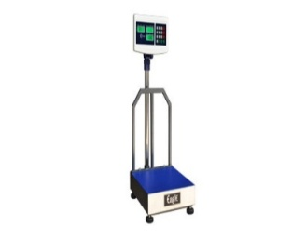
2 | DS5 | BENCH WEIGHING MACHINE | 0-10 KG | 3 | 
3 | PP4 | VEGETABLE CUTTING MACHINE | 0-200 KG | 2 | 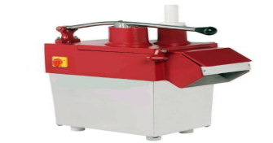
4 | WM1 | WET GRINDER TILTING MODEL 10 LTRS | 10 LTRS CAP | 2 | 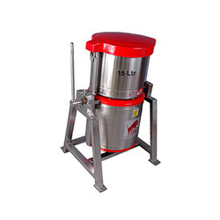
5 | KP4 | MICROWAVE OVEN | TABLE TOP | 2 | 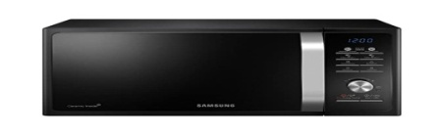
6 | KP5 | SANDWICH GRILLER | TABLE TOP 400X400X300 | 2 | 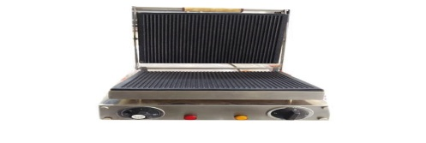
7 | DS6 | REFRIGERATOR 2 DOOR VERTICAL SS | 750X750X1950 | 2 | 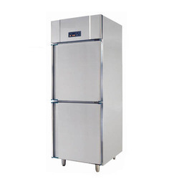
8 | CR1 | PRE FABRICATED PUF INSULATED COLD REFREGERATOR | 3750X2100X3000 (FIRST FLOOR) | 1 | 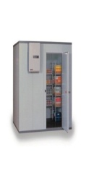
9 | CR1 | PRE FABRICATED PUF INSULATED COLD REFREGERATOR | 2800X3000X3000 (GROUND FLOOR) | 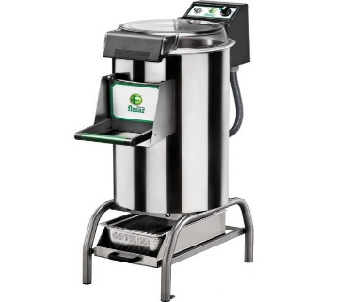  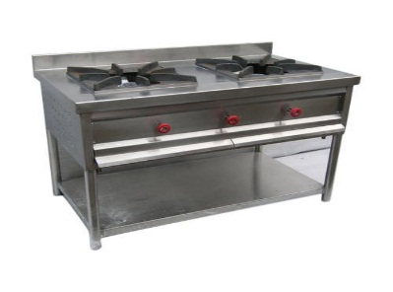  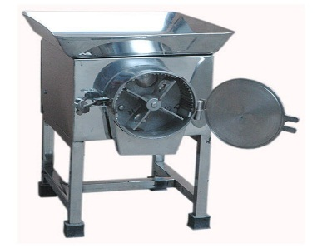  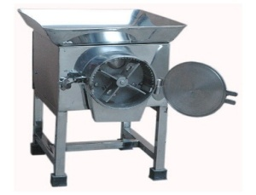  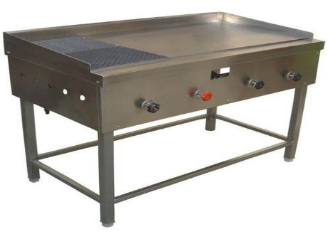  1 | 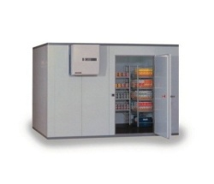
10 | WM2 | WET GRINDER TILTING MODEL 5 LTRS | 5-LTRS CAP | 2 | 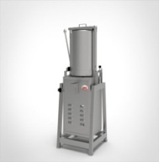
11 | WM3 | POTATO PEELER | 20-KG CAP (GROUND FLOOR) | 2
12 | WM4 | PULVERISER | 30-40 KG (GROUND FLOOR) | 2
13 | MK2 | TWO BURNER RANGE | 1500X750X600 | 7 | 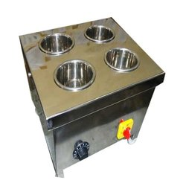
14 | MK5 | DOSA/CHAPATI PLATE CUM PUFFER | 1500X750X850 +150 | 4 | 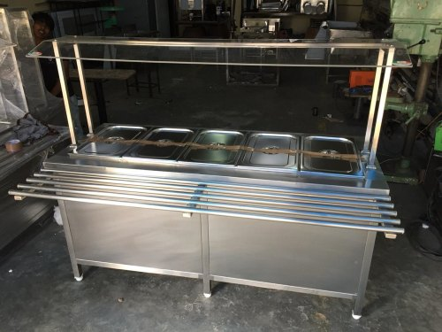
15 | FS1 | CULTERY/PLATE COUNTER WITH SPOON STERILIZER | 900X650(+300) X850 | 2
16 | FS2 | BAIN-MARIE COUNTER (WITHOUT GN PANS) | 1500X650(+300) X850 | 4 | 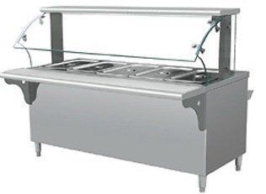
17 | KP2 | MIXER JUICER | TABLE TOP | 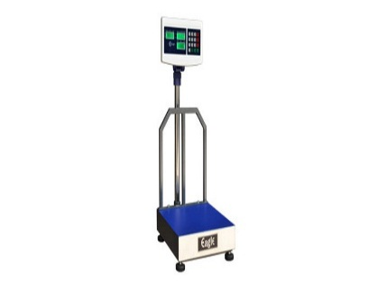  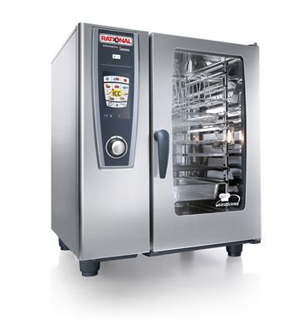  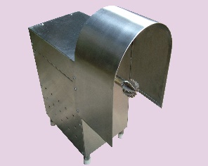  2 | 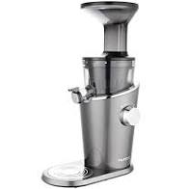
18 | KP6 | WORK TOP UNDER REFRIGERATOR | 1800X650X850 | 2 | 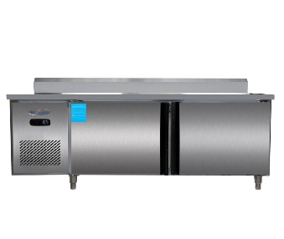
19 | KP8 | SALAMANDER WITH WALL MOUNTED BRACKET AND STAND | TABLE TOP 750 X500X400 | 2 | 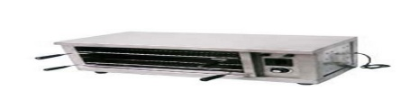
20 | KP9 | DEEP FAT FRIER | TABLE TOP -8 litres capacity | 4 | 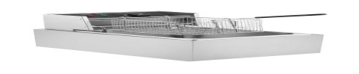
21 | MK4 | COMBI OVEN WITH STAND | 1200X1000X1500 | 2 | 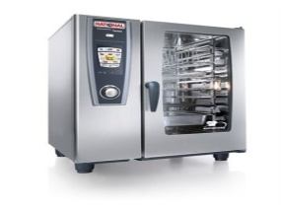
22 | WM5 | COCONUT SCRAPER | Table Top | 2 | 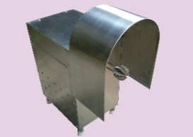
23 | PP8 | DOUGH KNEADER MACHINE | CAPACITY 40 LITRES | 2 | 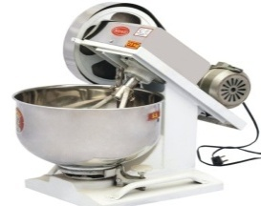
 |  | Total Cost of Items

Details Required to Raise Purchase Order
All the below fields are Mandatory, failing which the offer shall be summarily rejected.
Sr. No. | Description | Details
1 | Name and address on which purchase order is to be raised
2 | Bank details (attach copy of cancelled cheque)
3 | GST No. of the state on which Purchase Order to be raised (attached Copy of Certificate)
4 | PAN Card No. (attached Copy)
5 | HSN / SAC Code (8 digit) for each item.
6 | Delivery Schedule for Supply of Material.
7 | MSME / NSIC no. if any (attached copy of certificate)

Signature

Date: Name of authorized person for bidder with seal

BANK DETAILS FOR REFUND OF EMD
(Details to be filled by participant vendor)
*It is mandatory to fill following details for refund of EMD

Name of Account holder :

Bank name and Branch :

Account Number :

IFSC code :

PAN Card Number :

Contact Person’s Name :

Contact Person’s Number :

Email address :

(Name, Signature and Company Seal)

Place:

Date:
(Please enclose copy of cancelled cheque)
*Kindly contact Purchase Dept. in case of any change in above Bank Detail

